Designing an open source platform for capturing and analysing the implementation of COPUS protocol

Ad

On

On

Owns

Clicks

Webpages

Ankit Sharma (45155291)

Winter Reseasrch Scholar

ITaLI

Contents

1 About 3

2 Database Design 4

2.1 E/R Diagram 4

2.2 Relational Model 5

2.3 Tables 5

3 Website Design 5

3.1 Overview 5

3.2 Functionalities Across Pages 5

3.2.1 Add 1 Hour Activity data/ Add 2 Hour Activity data 5

3.2.2 Edit 1 Hour Activity data/ Edit 2 Hour Activity data 7

3.2.3 Add New Course Offering 8

3.2.4 Add Additional Activities 8

3.2.5 1 Hour Session Performance/ 2 Hour Session Performance 9

3.2.6 1 Hour Performance Trend/ 2 Hour Performance Trend 12

3.2.7 COPUS 14

3.2.8 FAQ 14

4 Next Steps 14

4.1 Security and Access control 14

4.2 Design Improvements 14

5 Development & Troubleshooting 14

5.1 Accessing current setup 14

5.2 Reference Sources 14

6 Github repository 14

# About

The aim of project is to provide a scalable way to implement COPUS protocols for quantifying aspects of teaching. The platform created will allow instructors to judge accurately how much time they are spending in active learning versus a more traditional lecture. This will allow instructors to make more informed decision about how they might modify their future class work. In short term, the project will trigger more active learning in lectures in UQ and in the long term allow other institutions to scalably implement COPUS research tool while meeting data privacy concerns.

The project is a stepping stone in ITaLI’s strategic activity of collaborating with UQ teachers to identify and share best teaching practices. The platform will allow ITaLI and participating staff to collect and interpret data about instructional activities in the classroom and how they correspond to student engagement and active learning.

COPUS protocols enable a reasonably objective measurement of the amount of class time spent on active learning activities and allow the instructor to make informed decisions about how they might modify their future class work. The project aims at creating a scalable platform to easily record and analyse activities across classes as described by the COPUS protocol. Deployment of this system will enable participating instructors and ITaLI to identify and shift from a traditional lecture to incorporate more active learning.

The project aims to fill the need of an open source scalable platform while meeting the data privacy requirements of the University to record and analyse classroom activity. Classroom observation protocol is already well recognised in academia, and while there is a COPUS analyser tool which builds upon the principles and is freely available for analysis, it cannot be used as it doesn’t meet the data privacy requirements. However, it still serves as a benchmark and can be as guidance to implement proven ideas.

The projects attempt to create the platform by hosting a database in UQ server and having a frontend website with users having access to concerned information. Hosting web pages for data entry and analysis will enable flexibility and scalability to the tool while having easy access control. There will be three categories of users: Data entry operators, Instructors and Administrator. Data entry operators will be responsible for entering classroom data and will access to those pages only, Instructors can analyse their performance alone, and the Administrator will have complete control over data entry and performance analysis of Instructors.

The project being open source will be available on Github, and the source code will be written under the guidance of the project supervisor (Dr Hassan Khosravi) and experienced members UQx programmers. The initial version was delivered on 31th July with the incorporation of feedback from esteemed and experienced members of ITaLI. The key audiences of the project will be Course Coordinators and Learning Designers, and their engagement will be ensured by demonstration of the project at various checkpoints and incorporate their feedback.

In the short term, the anticipated impact of the project is to trigger a shift towards active learning in lecturers by having unbiased data of class activity and allowing for instructors to make informed decisions about how they might modify their future class work. After a period of fine-tuning based on testing it at scale, the long-term impact is expected to be wider adoption of the platform across institutions as the project is fulfilling the need of allowing institutions to implement a successful idea easily at scale.

# Database Design

A backend database has been designed to store classroom activity data. The database has been designed to store activity data across courses which may part of one or various programs. One Instructor will be coordinating the course, and any number of instructors will be taking sessions. Each Instructor is part of a faculty, and each program is part of a faculty. In case of more than one person recording the information for a session distinct records are created for the same session.

## E/R Diagram

The database requirements were translated into the ER diagram below:

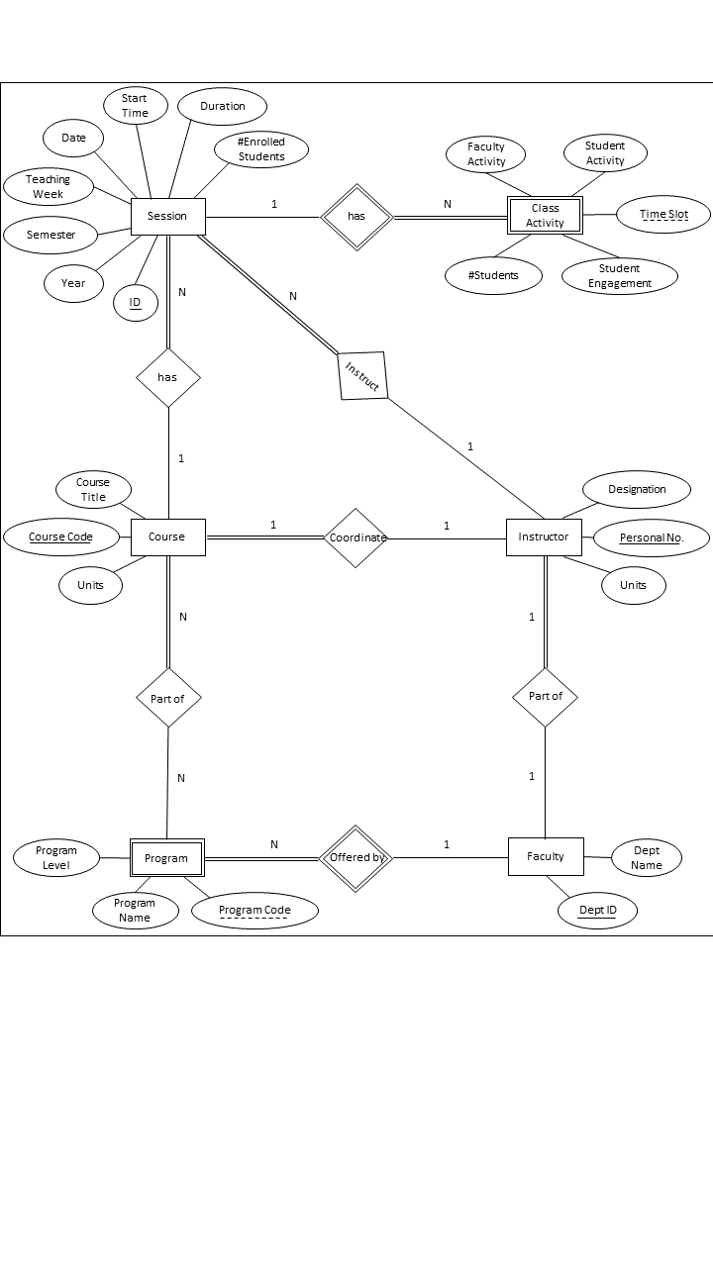

## Relational Model

Session[ID,Year,Semester, TeachingWeek, Date, StartTime,Duration,**CourseCode**,**PersonalNo**.]

Class Activity[TimeSlot,Faculty_Activity, StudentActivity,StudentEngagement, #Students,ID]

Course[CourseCode,Units,CourseTitle,**PersonalNo**]

Instructor[PersonalNo,Name,Designation ,**DeptID**]

Faculty[DeptID,DeptName]

Program[ProgramCode,ProgramName, ProgramLevel, DeptID]

Program_Course_Relationship[ProgramCode,CourseCode]

*Foreign Keys:*

Program.DeptID Faculty.DeptID

ClassActivity. ID Session.ID

Instructor.DeptID Faculty. DeptID

Course. PersonalNo Instructor. PersonalNo

Session.CourseCode Course.CourseCode

Session. PersonalNo Instructor.PersonalNo

ProgramCourseRelatopnship.ProgramCode.ProgramCode Program.ProgramCode

ProgramCourseRelatopnship.CourseCode Course.CourseCode

## Tables

Code for database creation along with the population of sample values has been shared on Github and can be accessed for further information

# Website Design

## Overview

The dashboard broadly consists of two parts: Data Entry & Data Analysis. The Data tab allows the user to add session data, edit session data recorded in the database, add new courses and additional activities to record in the session. The Analyse Data tab allows the user to understand the activities performed by faculty and student alike and gauge their impact on engagement in one session or across the sessions of an instructor for a particular course in the chosen semester. Currently, it is possible to record and analyse sessions of one-hour duration with work being done on adding the class activity of 2-hour sessions.

## Functionalities Across Pages

### Add 1 Hour Activity data/ Add 2 Hour Activity data

The page has two tabs: Add data and Preview

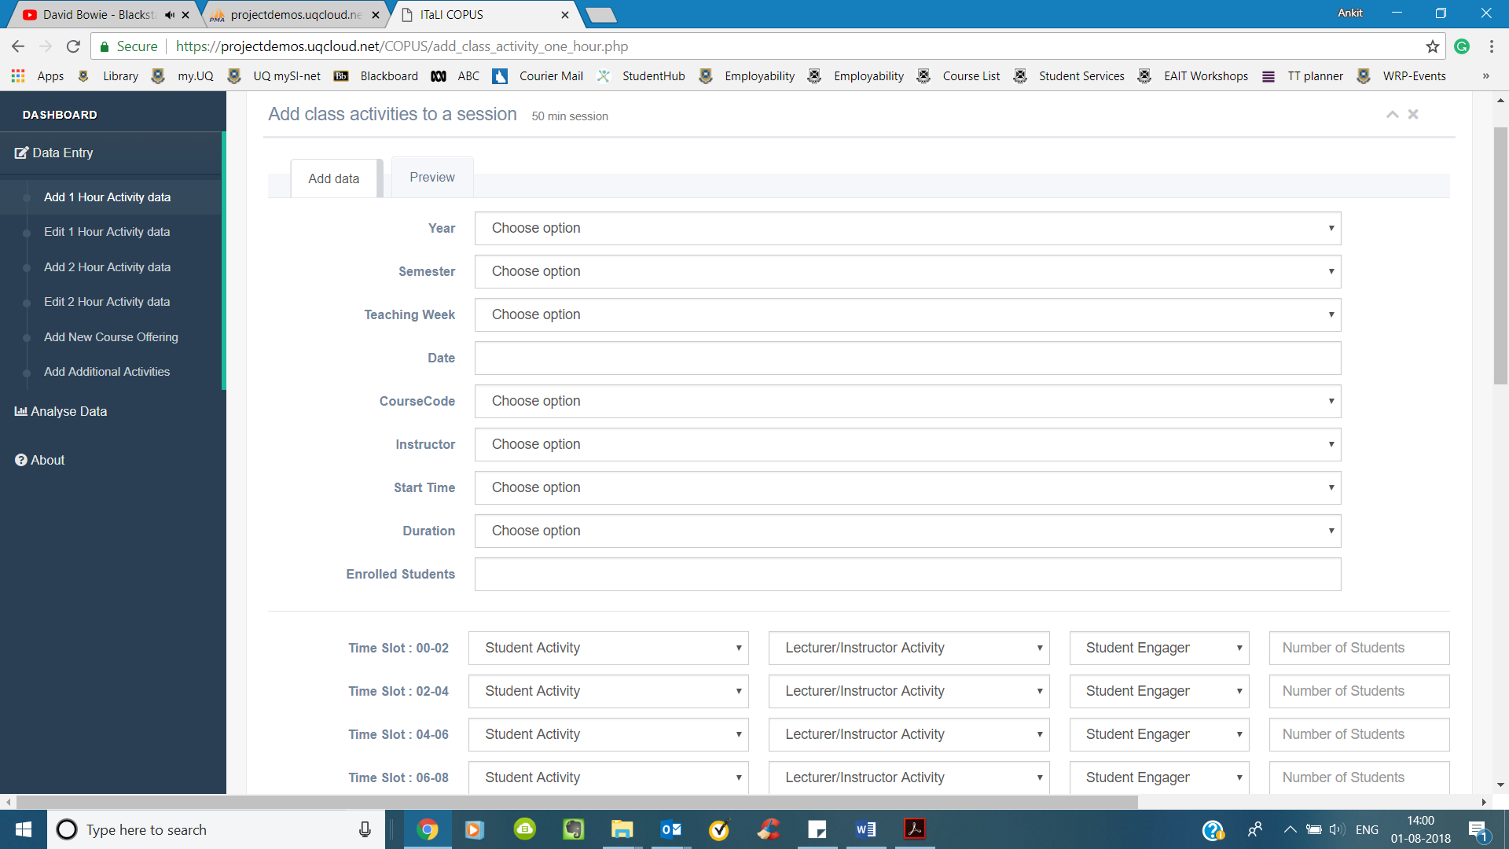

For entering class activity data about an existing course, the user will have to fill details about the session and enter the information about the following at every two-minute interval:

* Student Activity
* Faculty Activity
* Student Engagement
* Number of Students in the class



The drop-down values for each selection is fetched from the database so that with the entry of new options in the database, for example, new faculty activity for doesn’t require changes in the frontend. Additionally, the code checks that all values are selected before preview or submission.

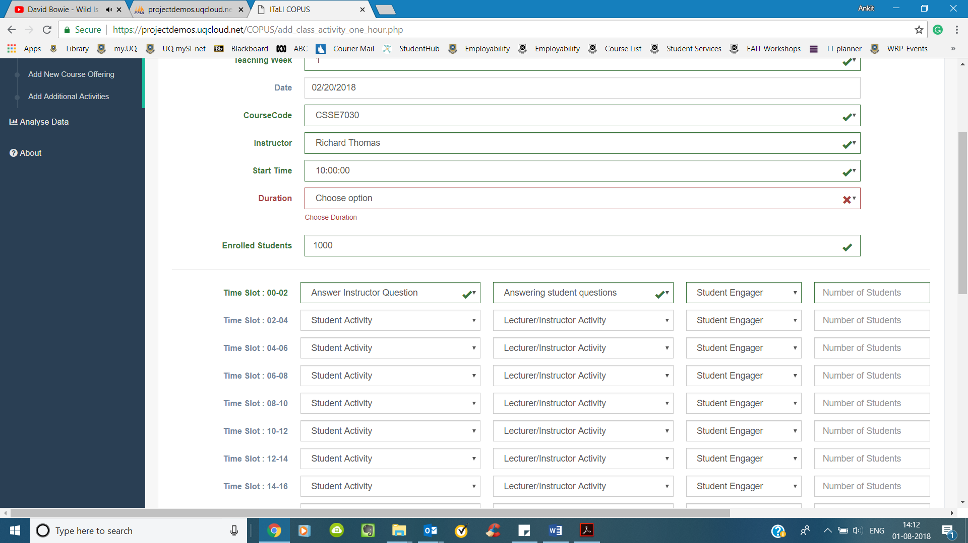

Once the user has selected all the values, they can preview it before submission or directly add it to database

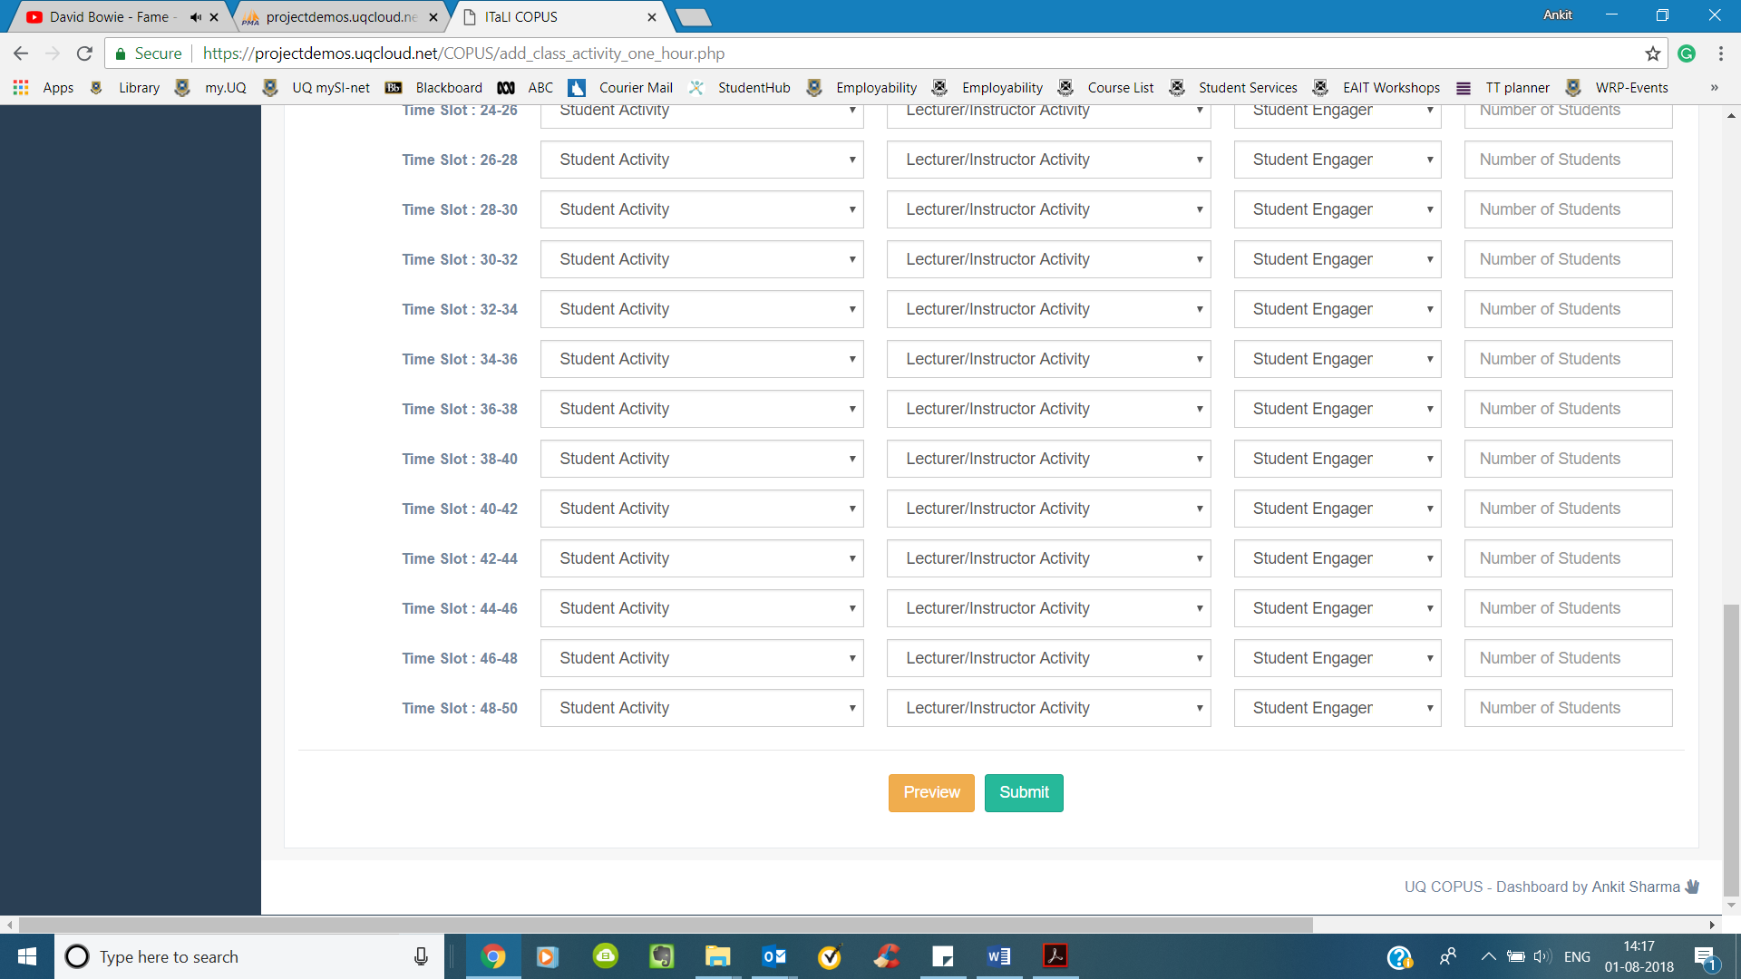

The preview tab, next to add data tab will be populated once the user clicks on the preview button and the user has the option of either adding it to a database or discarding it.

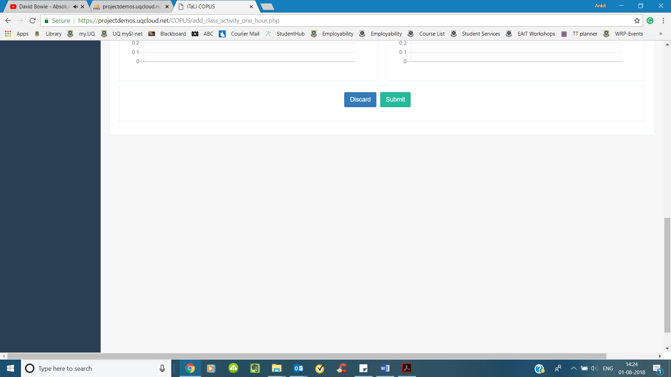

### Edit 1 Hour Activity data/ Edit 2 Hour Activity data

The User can edit activities in a session from this page. First, the user has to select a session they want to edit

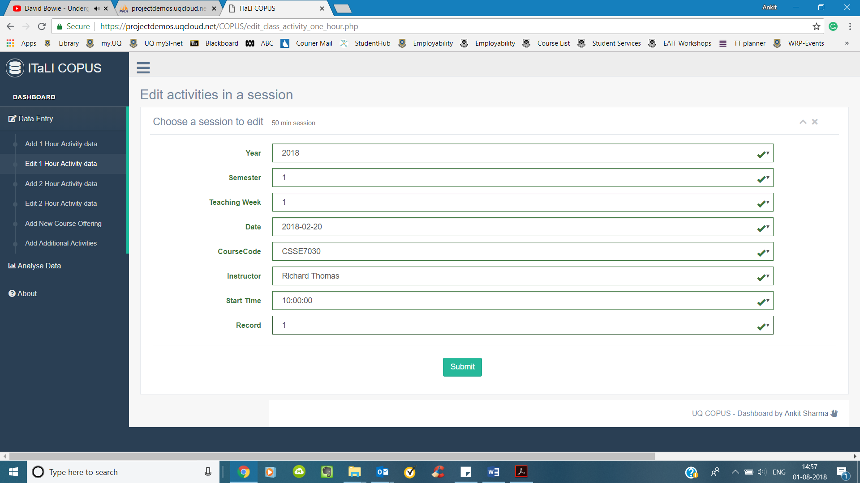

On pressing submit button, they are taken to another page with data in the session. To change a value, they need to select a new value from the dropdown and click on the change button.

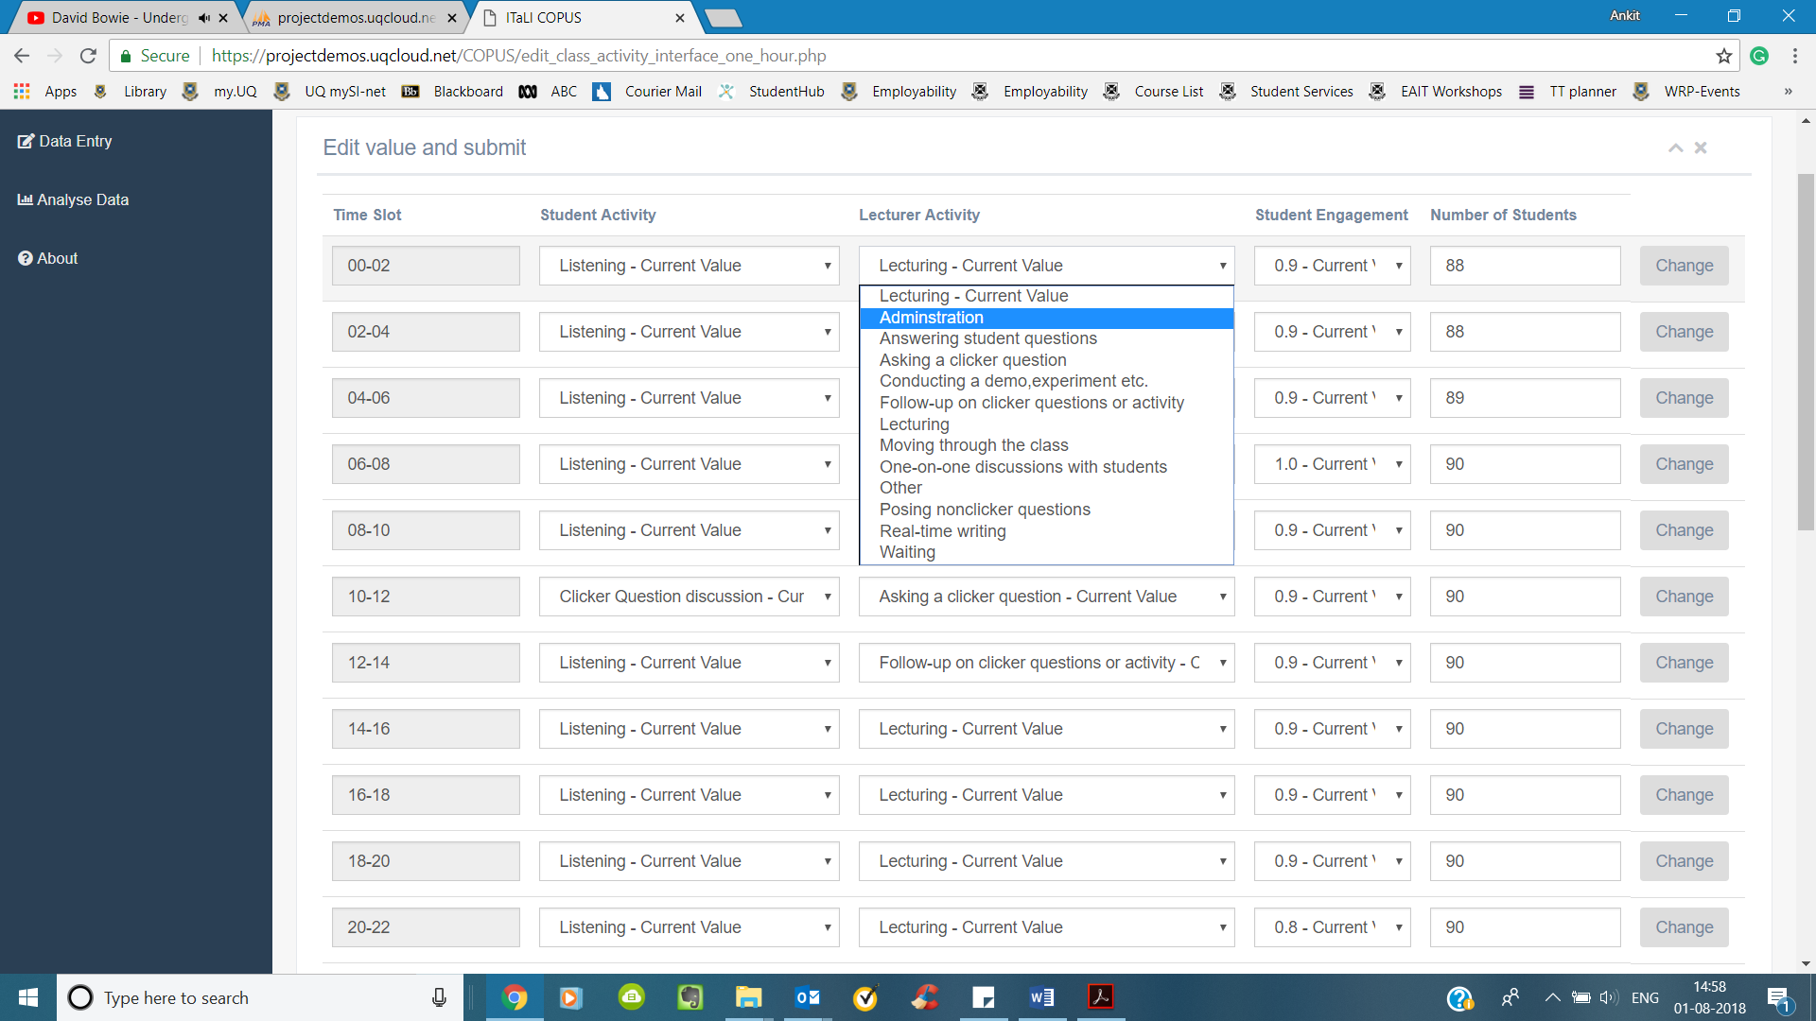

On pressing change button, the user will be redirected to another page with the message “Record has been updated” and can press Go Back button to go back to the previous page

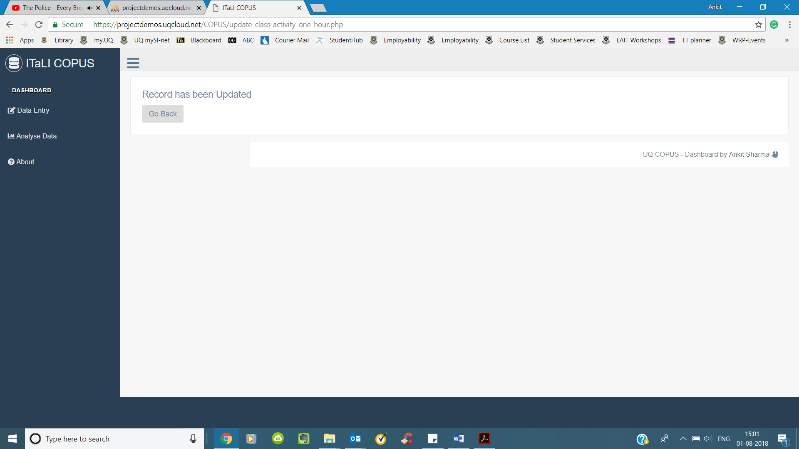

### Add New Course Offering

Recognising the fact new instructors, courses etc. would have to be added to the database the page provides an interface for the user to add the same

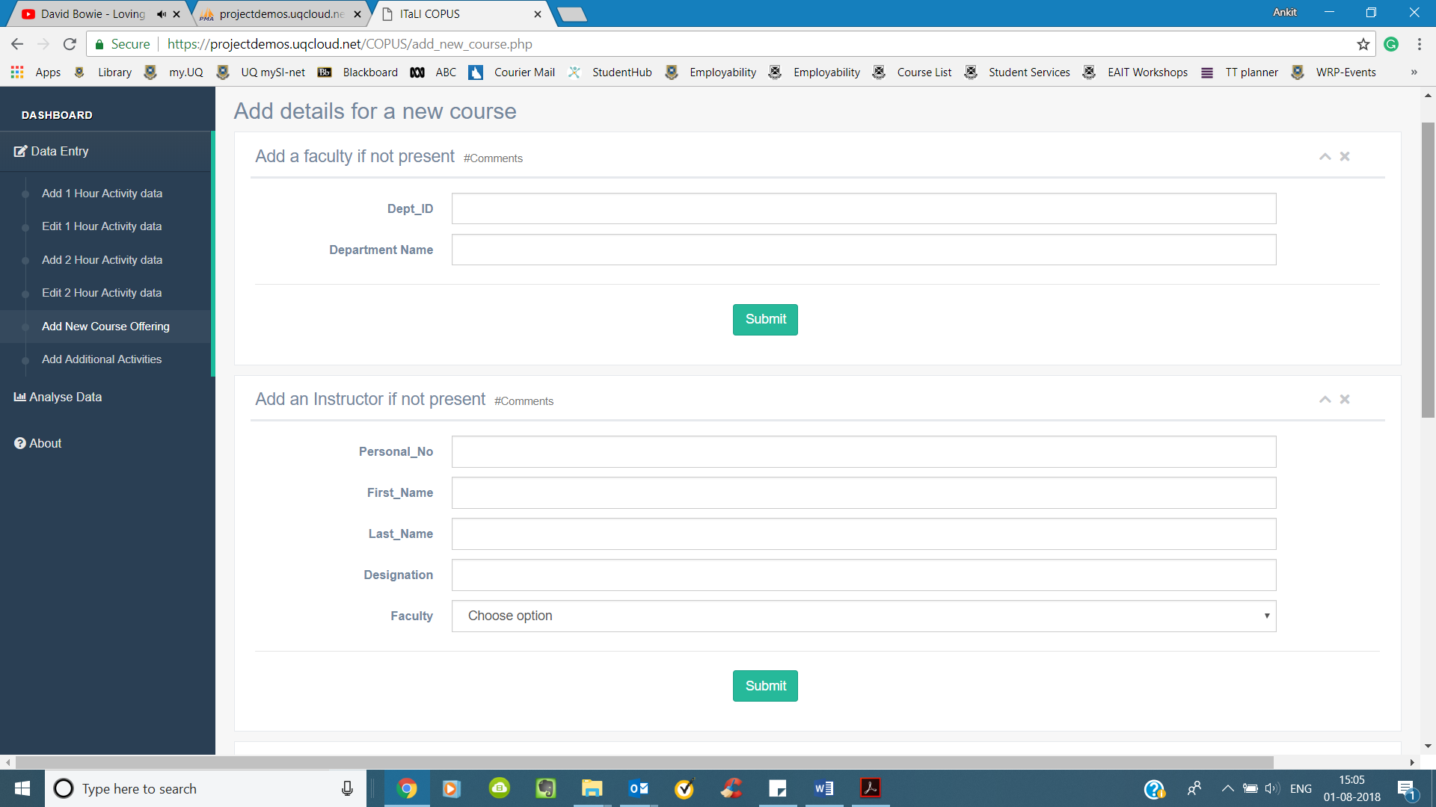

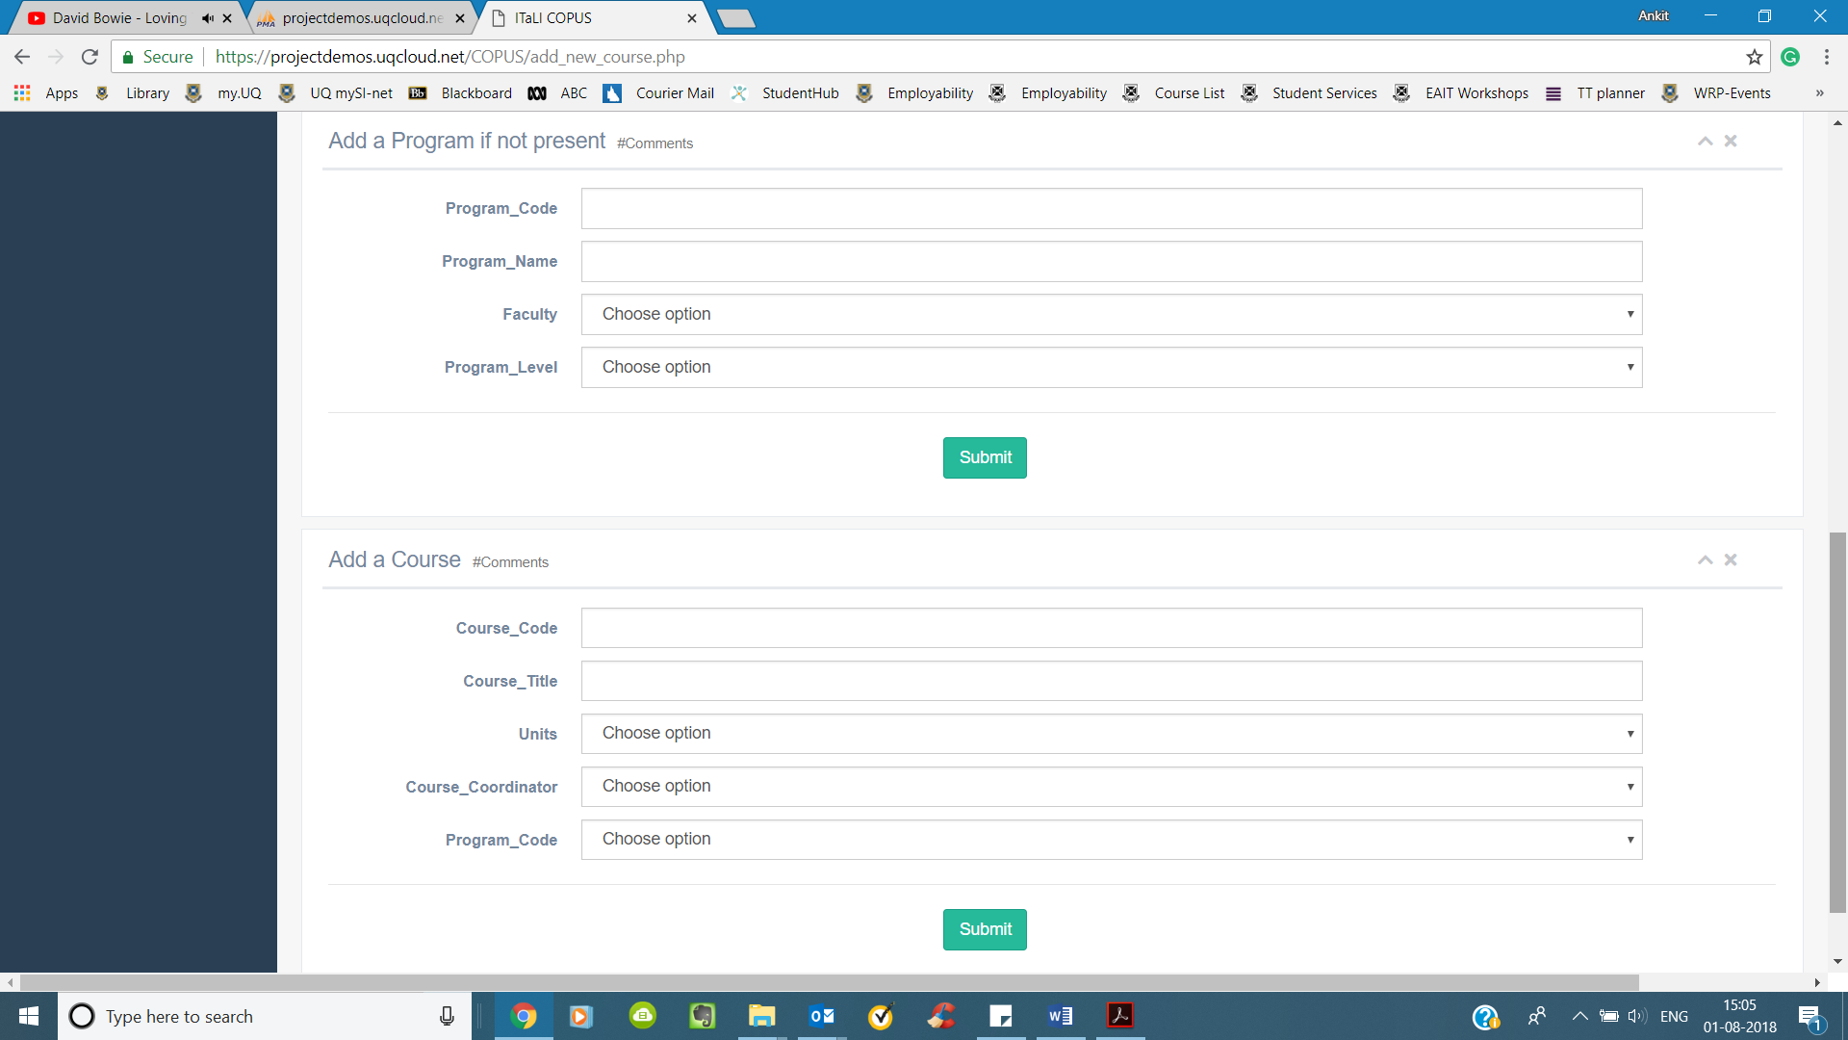

### Add Additional Activities

This page allows the addition of additional instructor and student activities

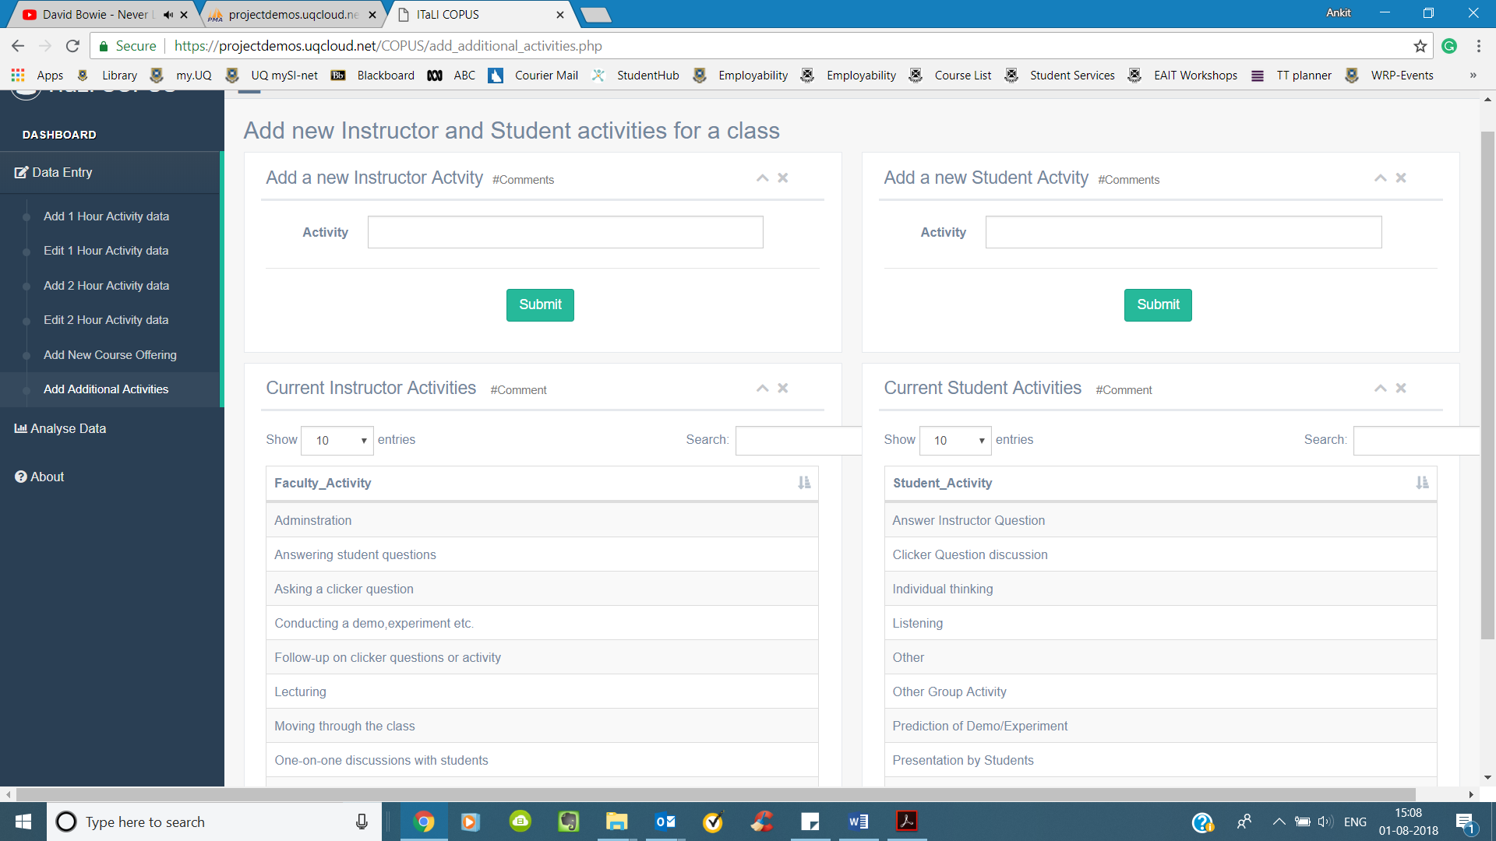

The user can check whether the required category is already present from the table and add it accordingly

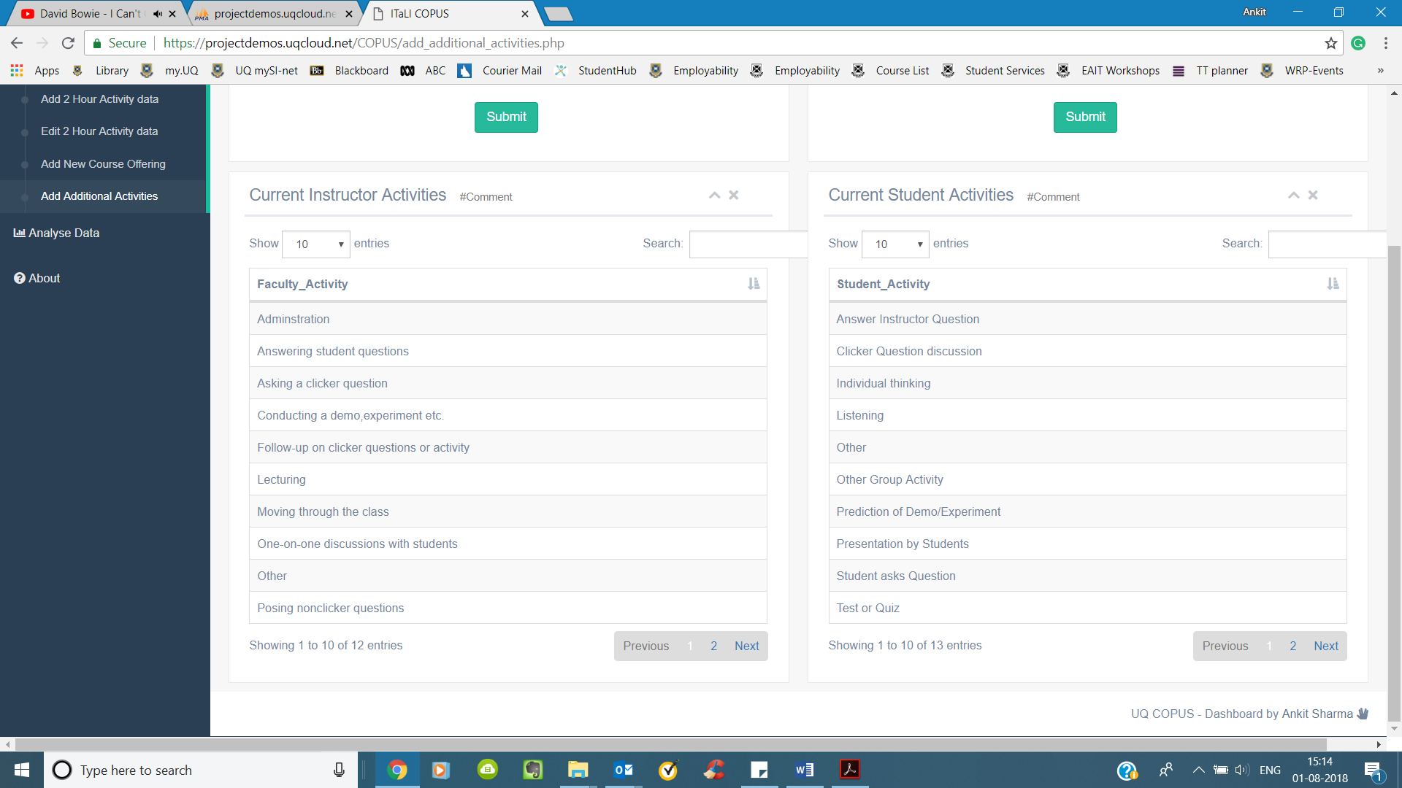

### 1 Hour Session Performance/ 2 Hour Session Performance

The page allows the user to choose a session and see the basic stats for the same

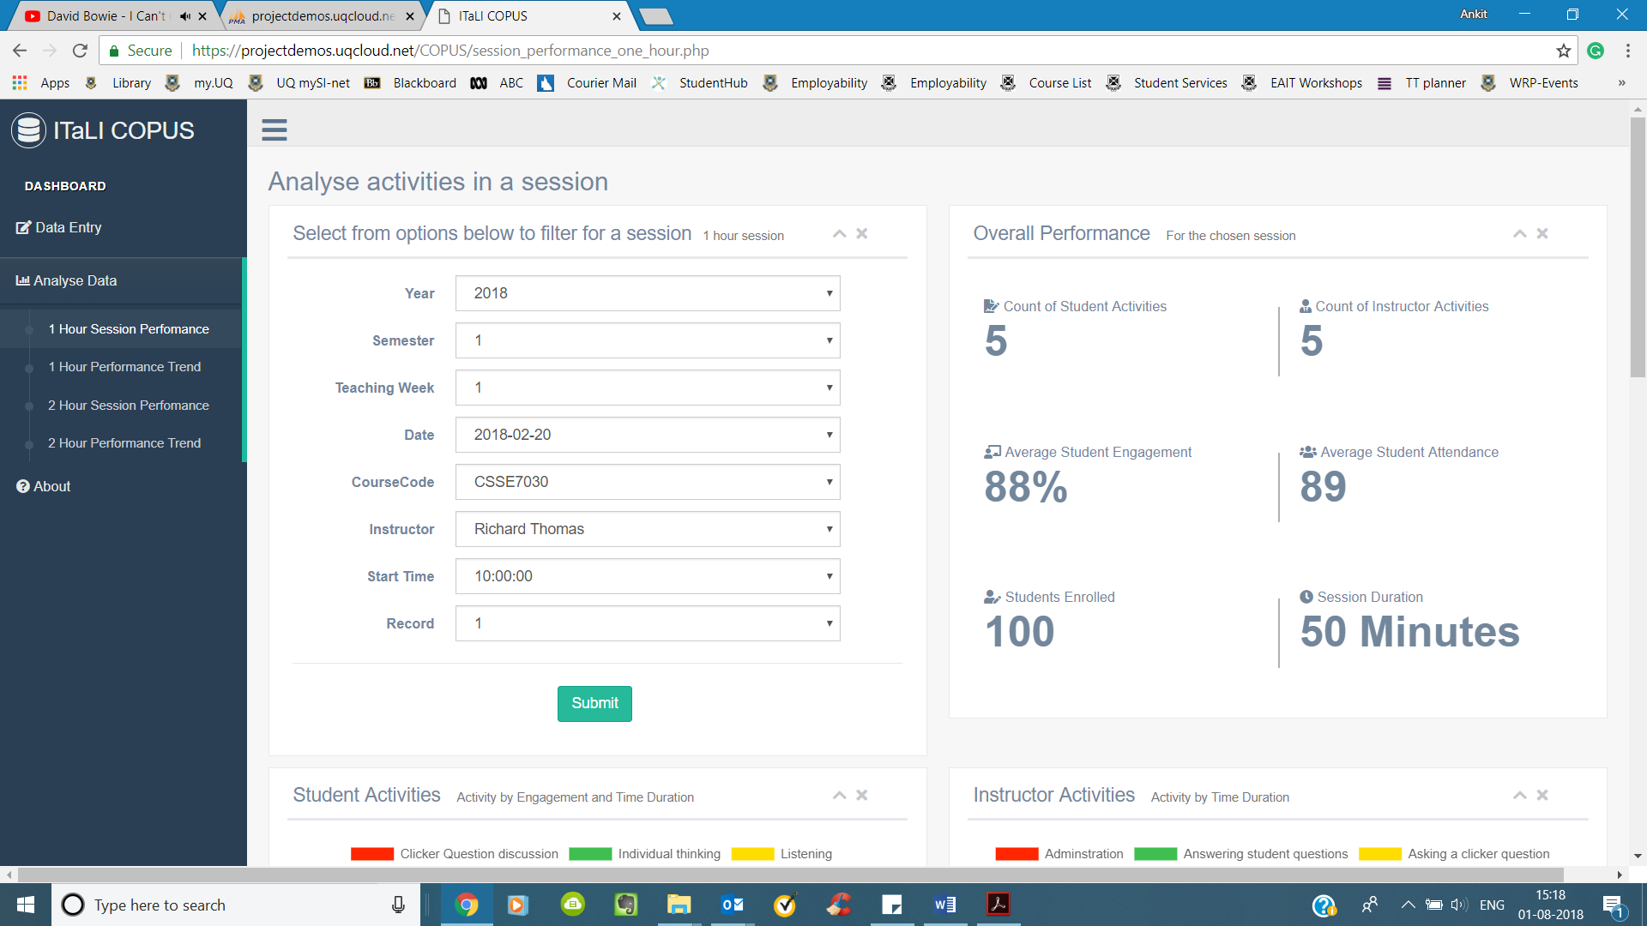

The overall performance is shown for the session:



* Activities students by there engagement and time duration

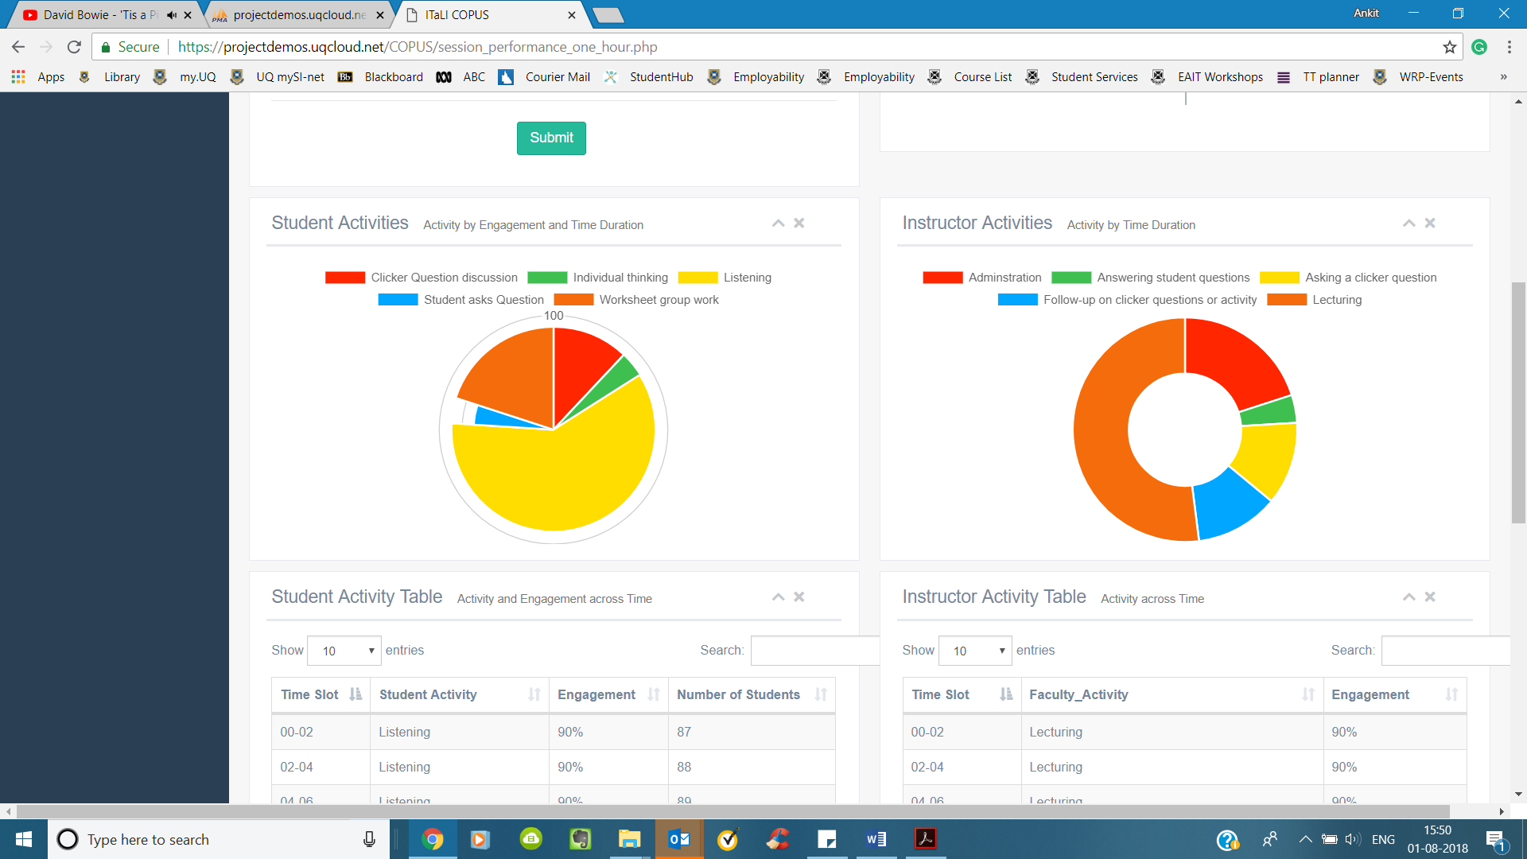

* Instructor Activities by the time duration



* Student activity, engagement and strength for every time slot

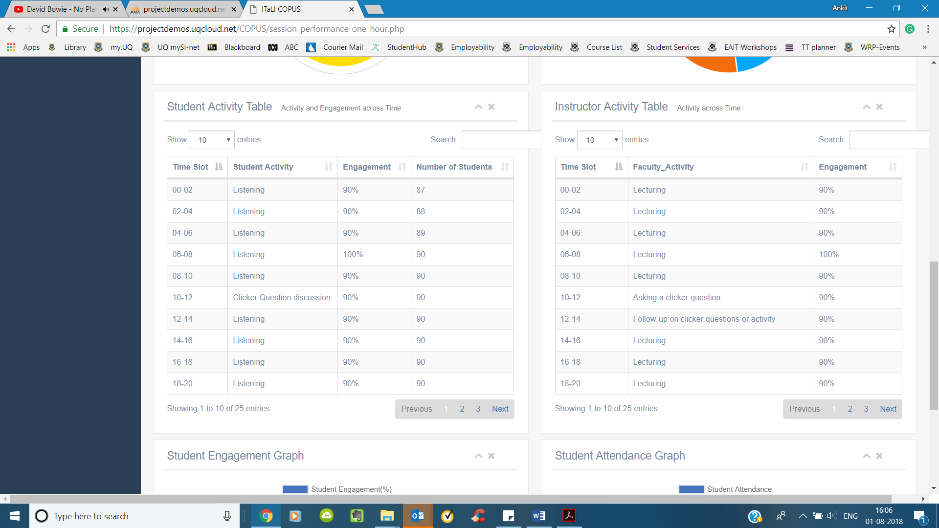

* Faculty activity and engagement for every time slot



* Student Engagement Trend

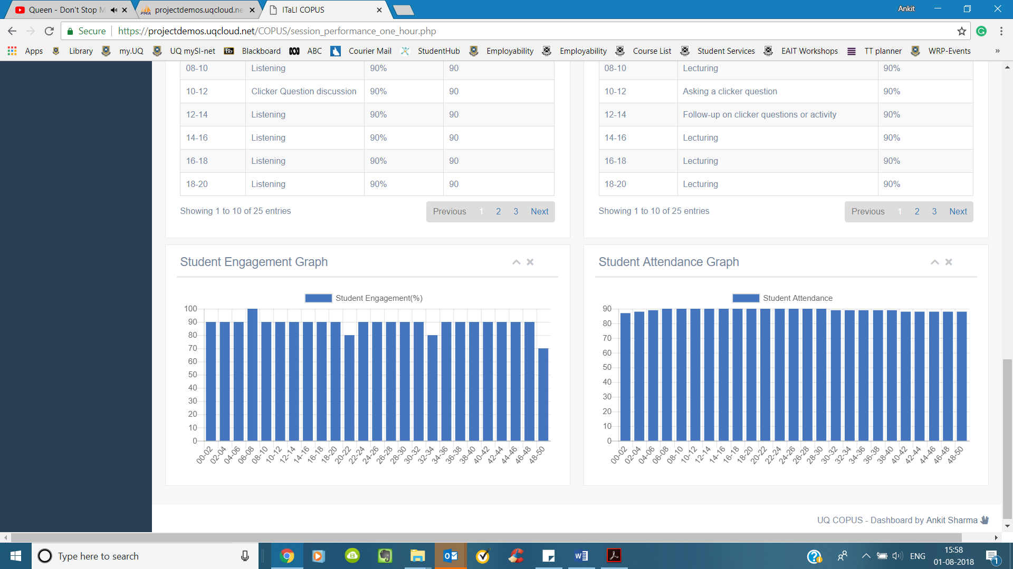

* Student Attendance Trend



### 1 Hour Performance Trend/ 2 Hour Performance Trend

The page allows the user to see the performance trend for an instructor teaching a course in the chosen semester

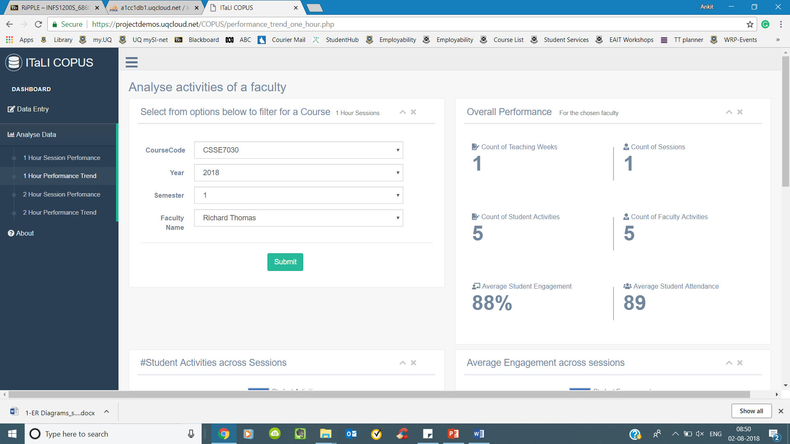

The overall performance is shown for the instructor:



* Count of student activitities across sessions

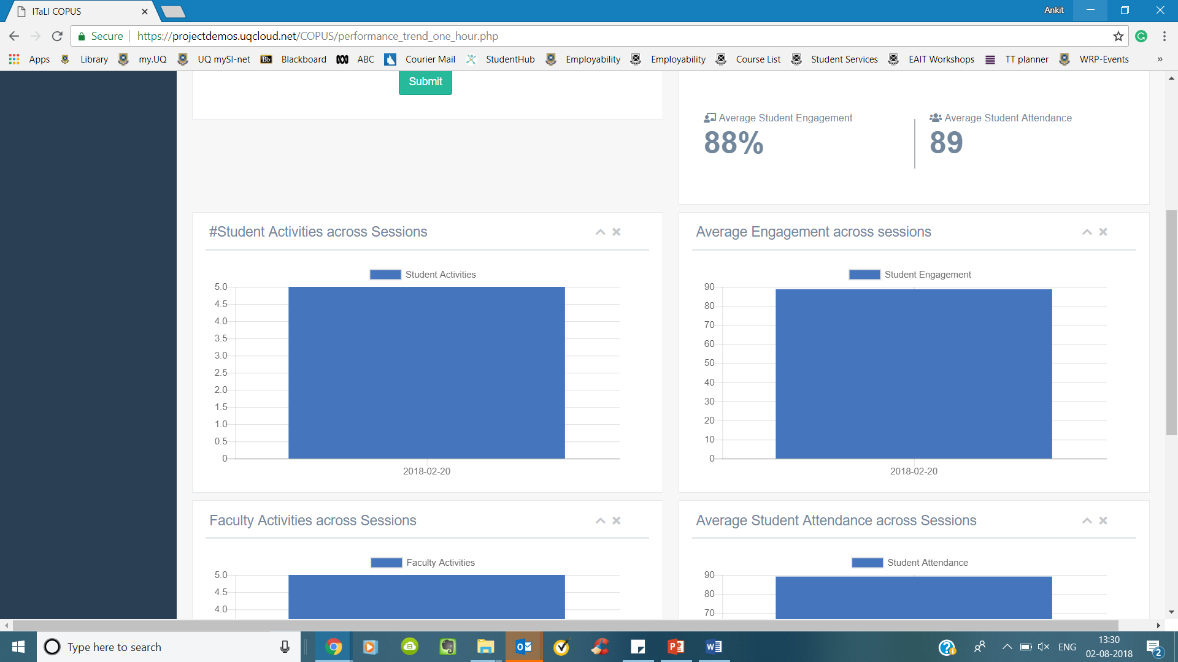

* Average Engagement across sessions

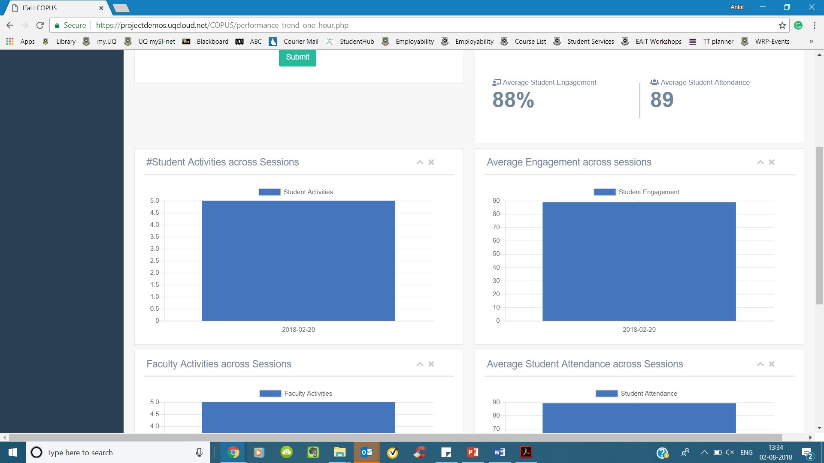

* Count of Faculty activities across sessions

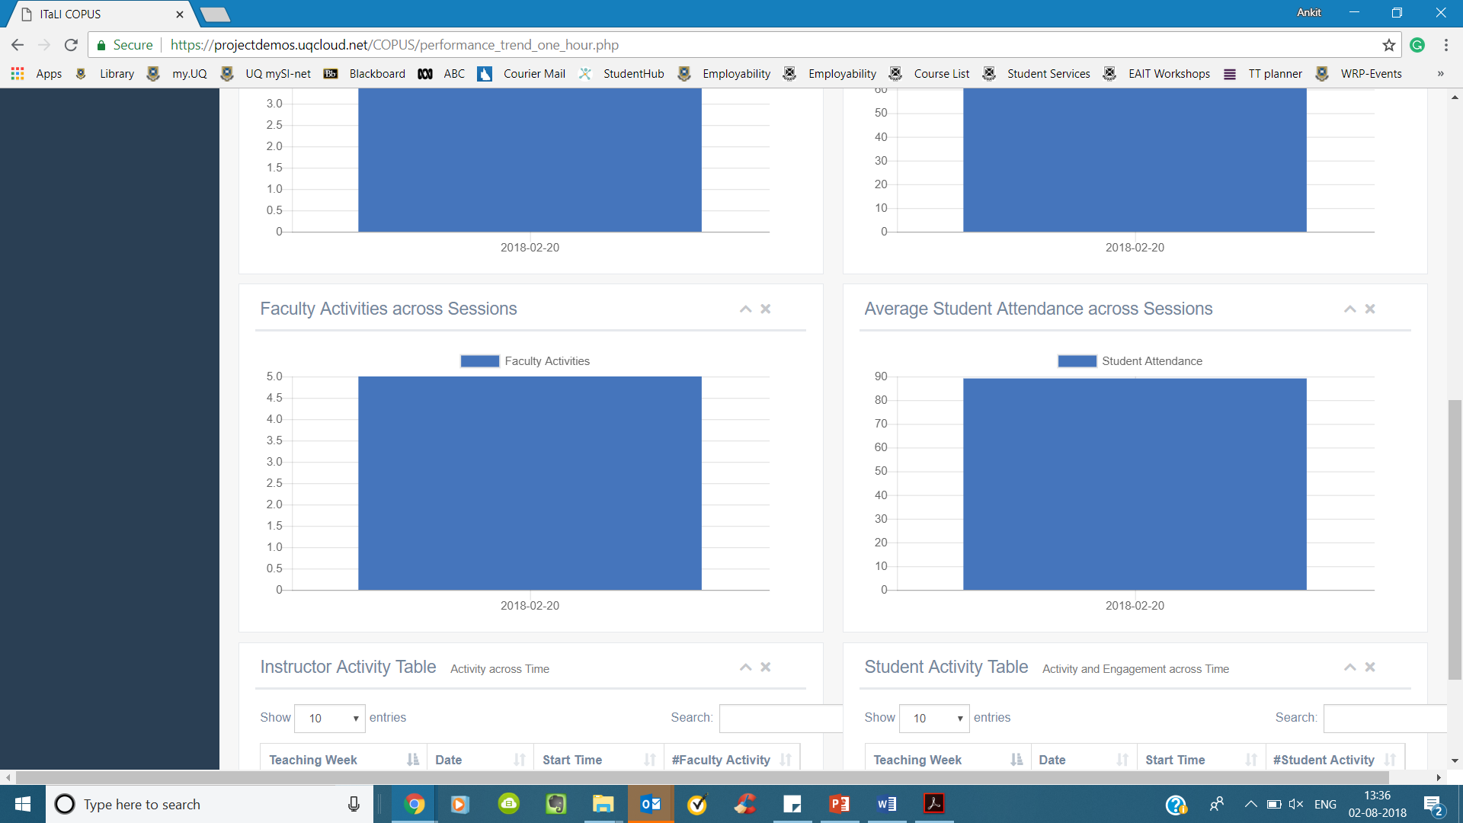

* Average Student attendance across sessions

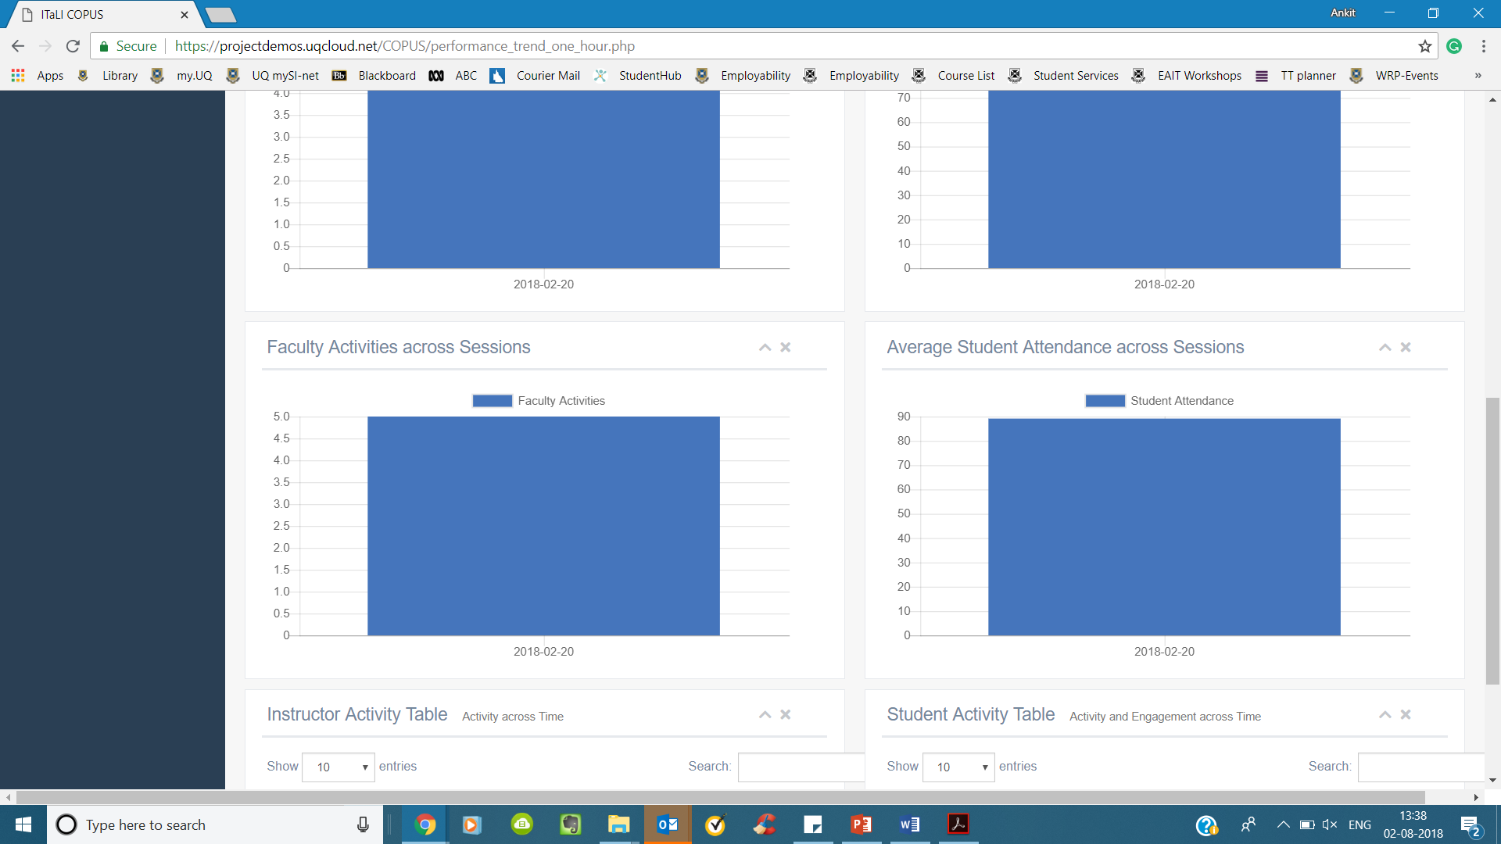

* Instructor Activity table

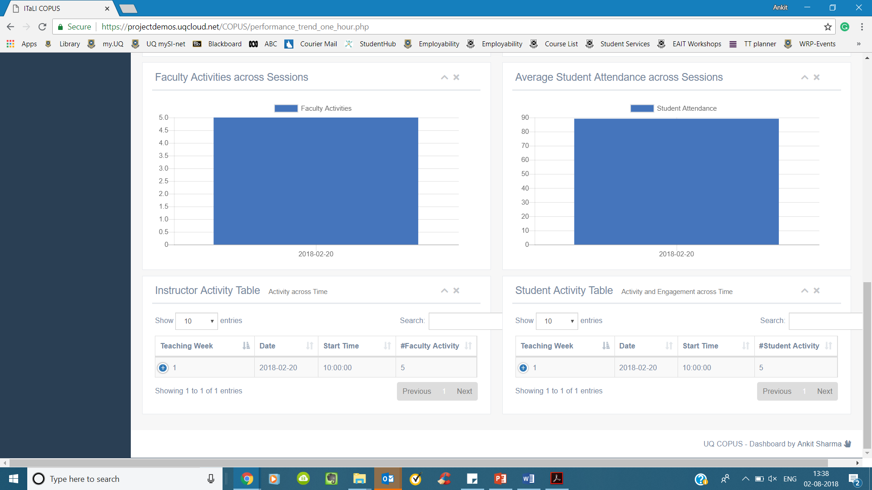

* Student Activity Table

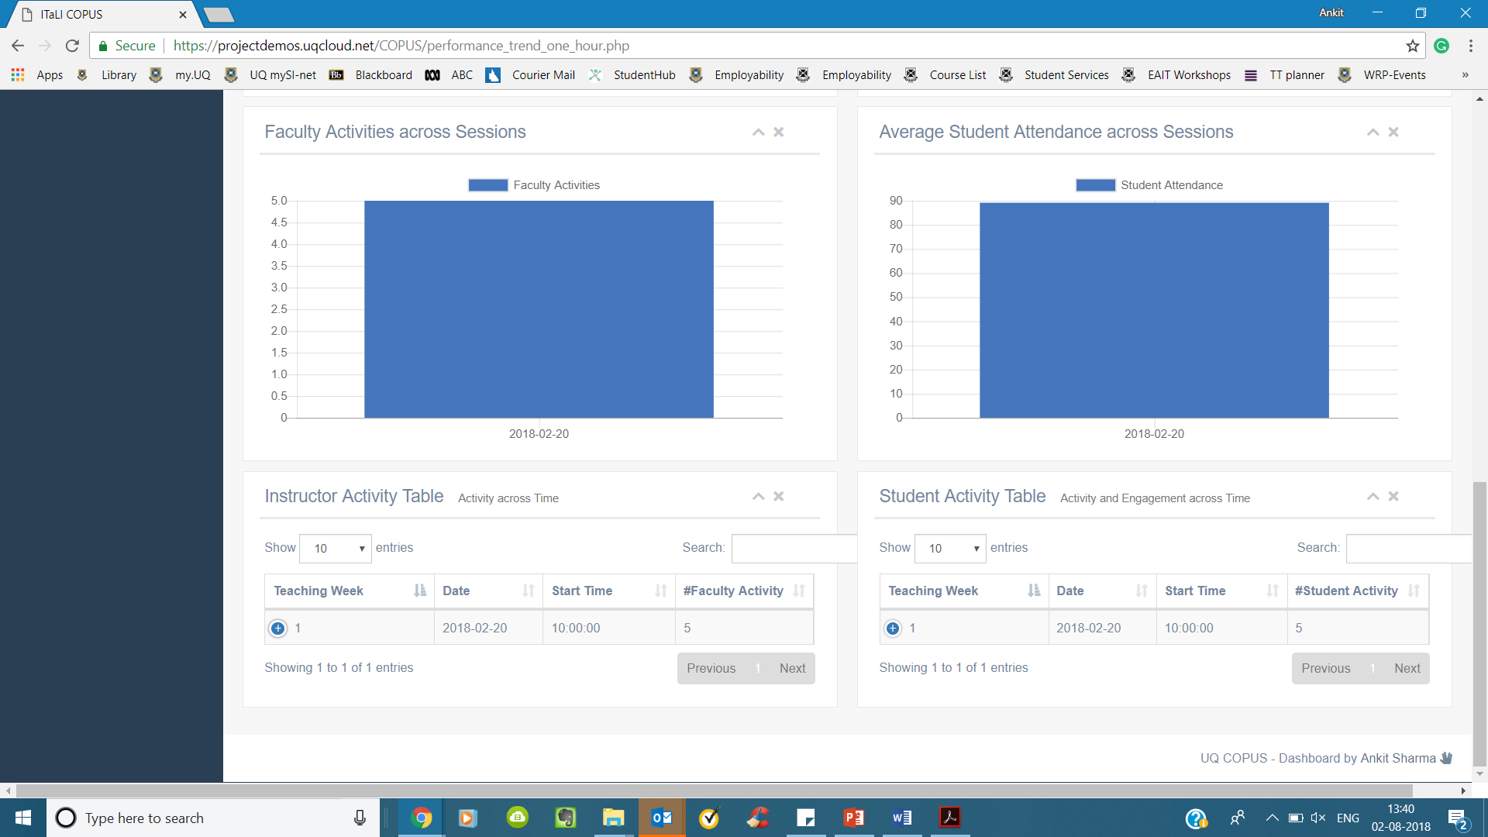

### COPUS

Currently, the page is empty, but it can be populated with relevant information

### FAQ

Currently, the page is empty, but it can be populated with relevant information

# Next Steps

## Security and Access control

The next major step is to move the tool from eait server to uq server and provide the user access to parts of the website and data based on their role. Based on data entered using UQ Single Sign On the role of user will be determined and they would access relevent pages and information. The User roles will be as follows:

|  |  |  |  |  |  |
| --- | --- | --- | --- | --- | --- |
| **Access** | | **Admin** | **Course Coordinator** | **Instructor** | **Data Entry Operator** |
| Add Data | Page | ✔ | ✔ | ✔ | ✔ |
| Data | ✔ | Only for their course | Only for their session | ✔ |
| Edit Data | Page | ✔ | ✔ | ✔ | ✔ |
| Data | ✔ | Only for their course | Only for their session | ✔ |
| Add Course | - | ✔ | **X** | **X** | ✔ |
| Add Activities | - | ✔ | ✔ | ✔ | ✔ |
| Session Performance | Page | ✔ | ✔ | ✔ | **X** |
| Data | ✔ | Only for their course | Only for their session | **X** |
| Performance Trend | Page | ✔ | ✔ | ✔ | **X** |
| Data | ✔ | Only for their course | Only for their session | **X** |

## Design Improvements

Along with the above, the following design improvements will be made to the interface

1. In the ***edit_class_activity_interface*** page replace the change button repeated for every timeslot with a single change button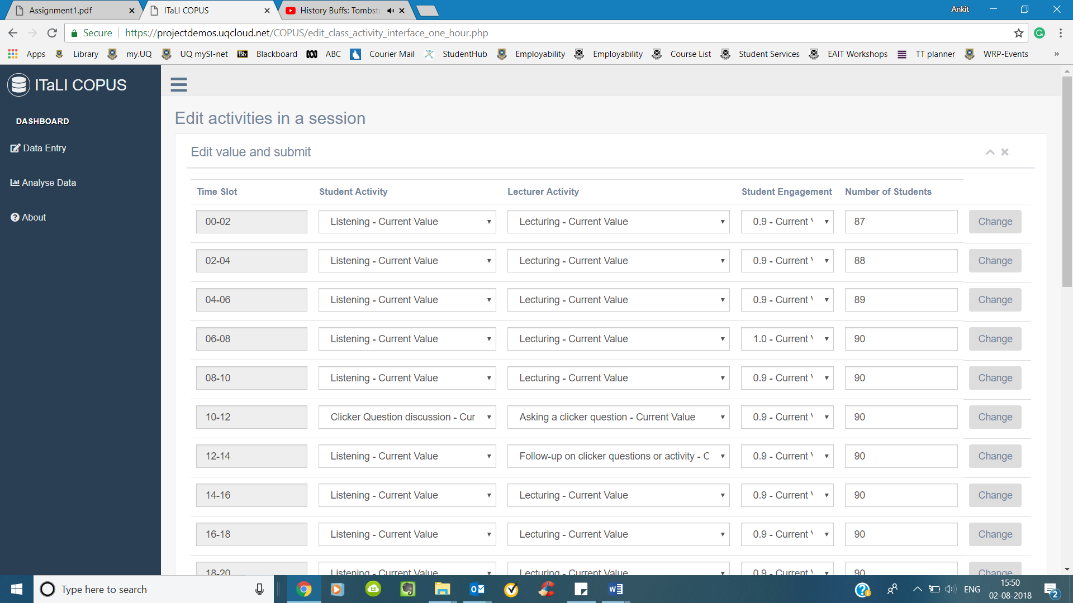
2. Properly render the search bar across various pages

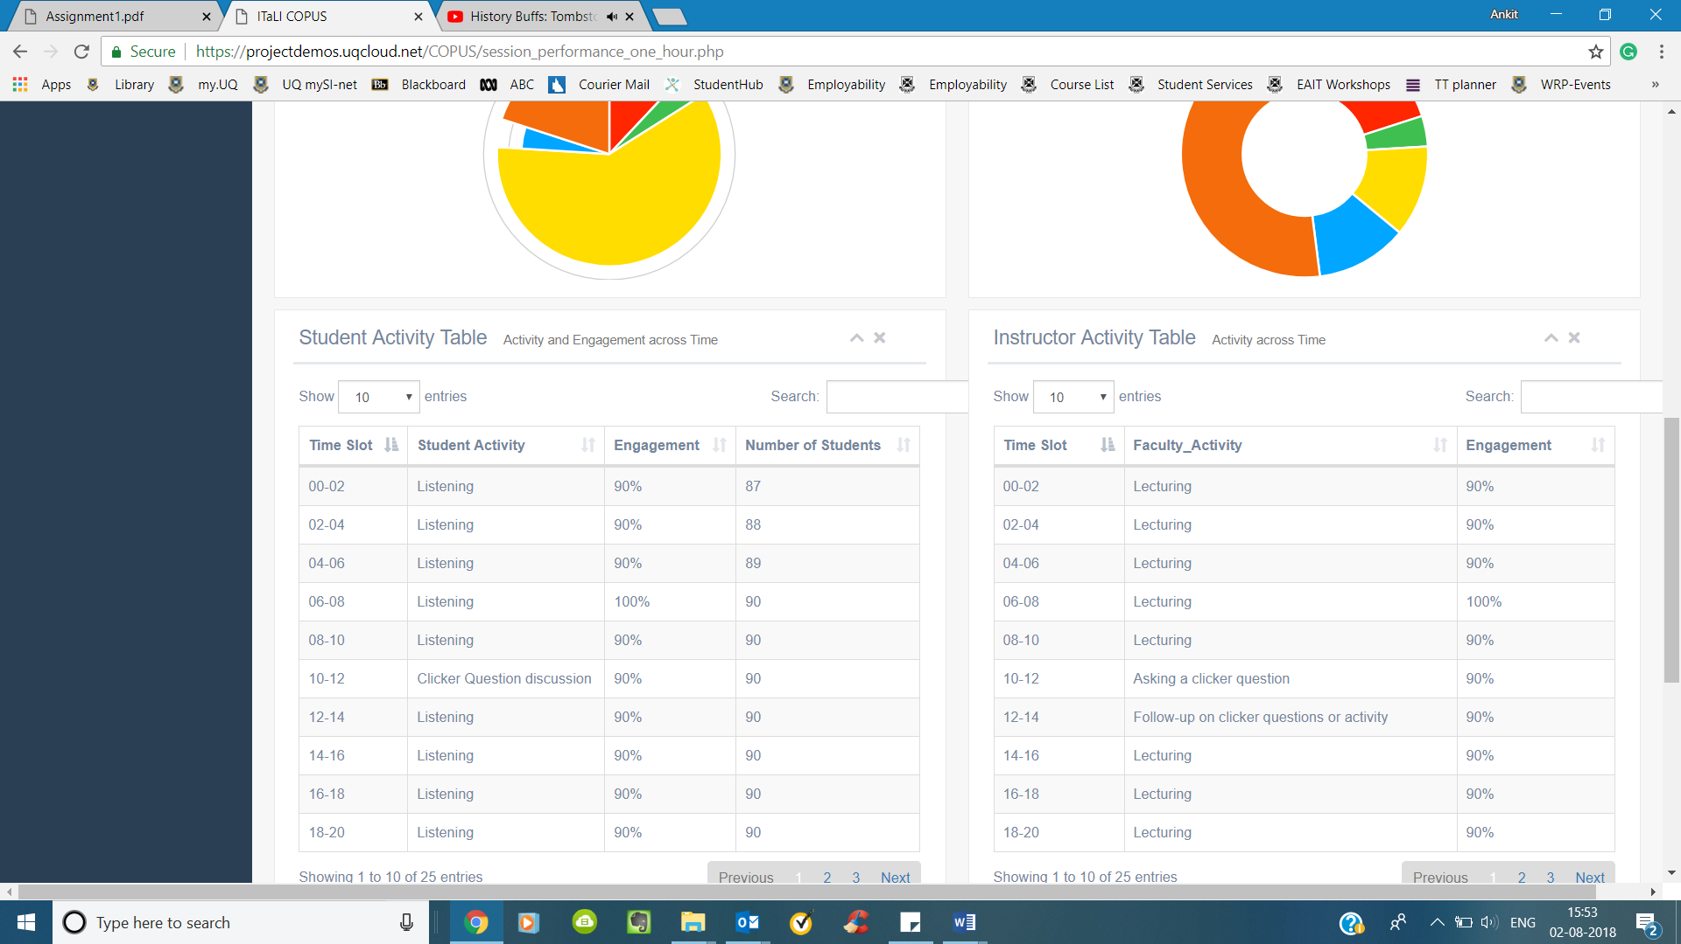

1. Use react framework to render time slot rows (shown in figure below) in **add_class_activity** page

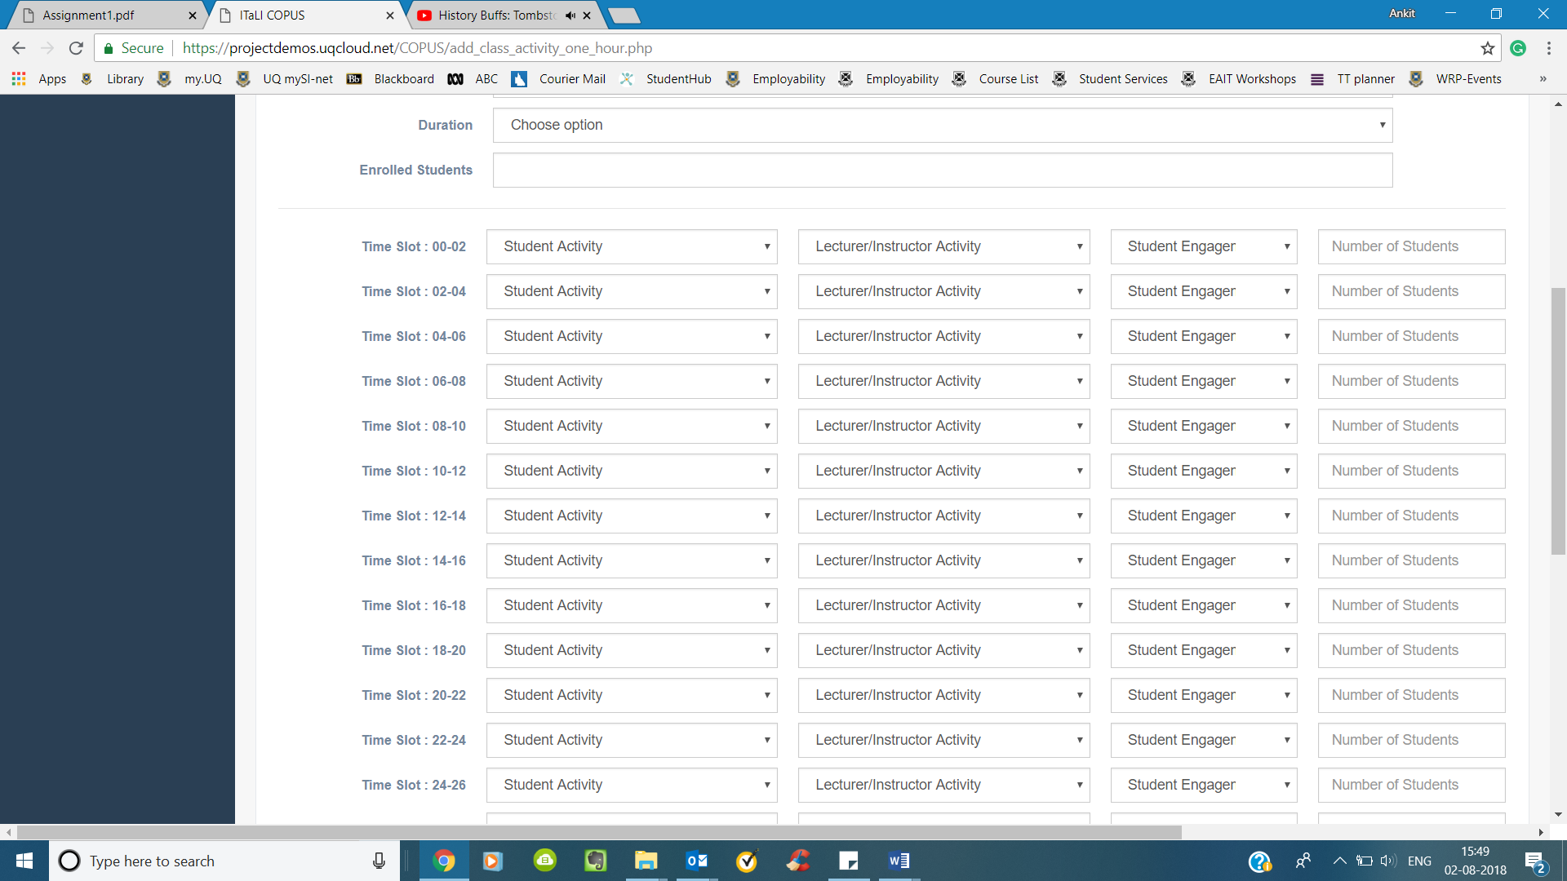

1. Filter based on existing values

Currently, all options from the database are shown as options in dropdown menu. The next step would be to filter successive options based on values selected. For example. One Semester 1 is selected the user should get only those records from data base which are present for 2018 (Year filter) and Semester 1 (Semester filter)

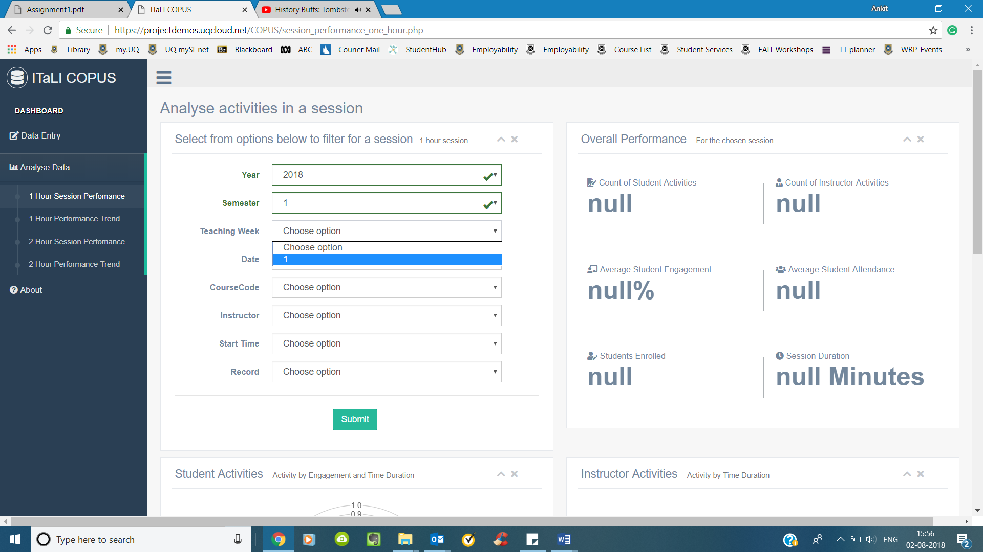

1. Additional analysis pages

Currently, there are only two analysis pages: Statistics for one session and statistics for a course across semester. It is possible to have additional analysis pages based on feedback after testing the tool.

# Development & Troubleshooting

## Accessing current setup

### Phpmyadmin

Link <https://projectdemos.uqcloud.net/phpmyadmin/>

### Website

Link: <https://projectdemos.uqcloud.net/COPUS/add_class_activity_one_hour.php>

### Filezilla

The login credentials are as follows:

hostname : projectdemos.zones.eait.uq.edu.au

username: sXXXXXXX

password: user password

port: 22

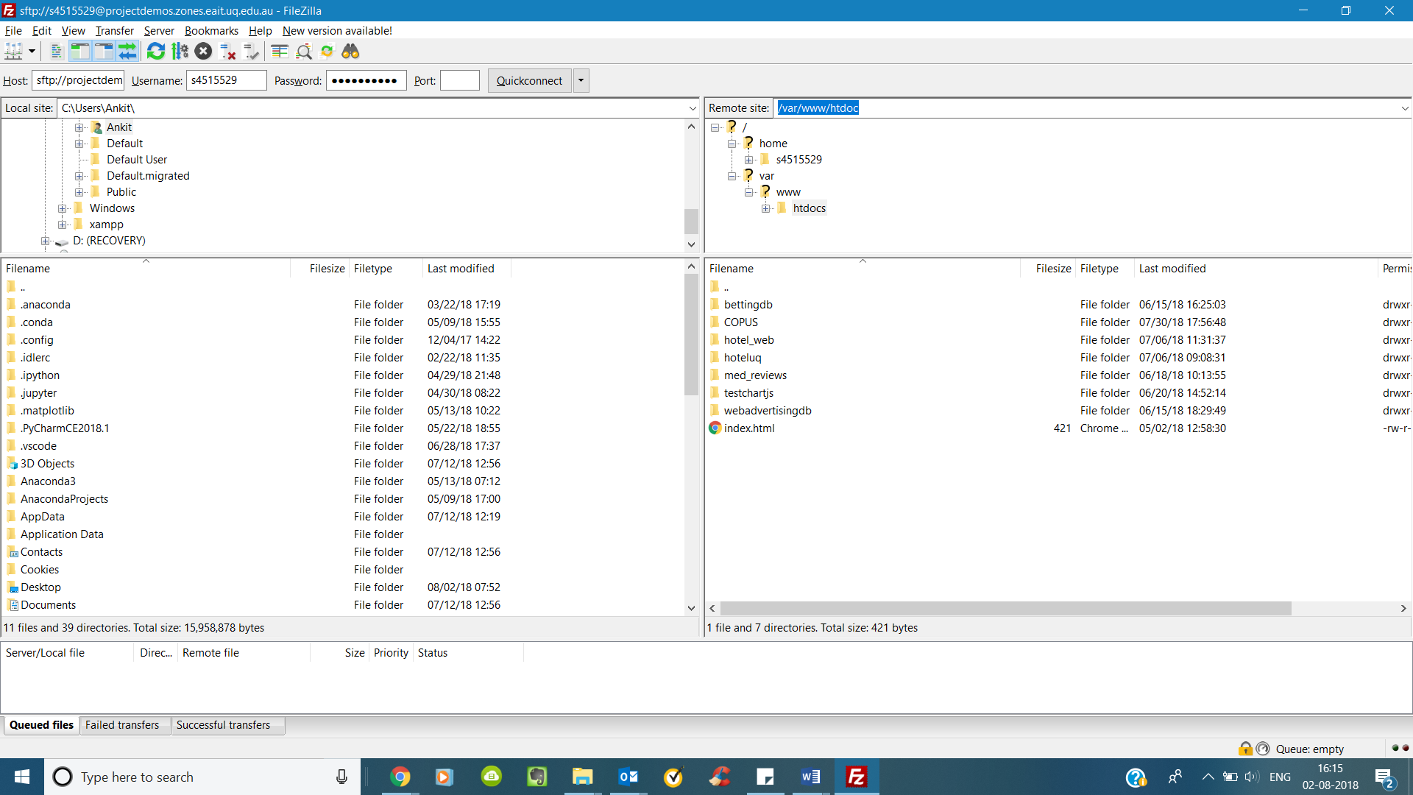

Enter /var/www/htdoc in the remote site to access COPUS data

### Accessing SQL error log

1. Open putty and enter the following details:

Hostname (or IP address): mdatascience-projectdemos.zones.eait.uq.edu.au

Port: 22

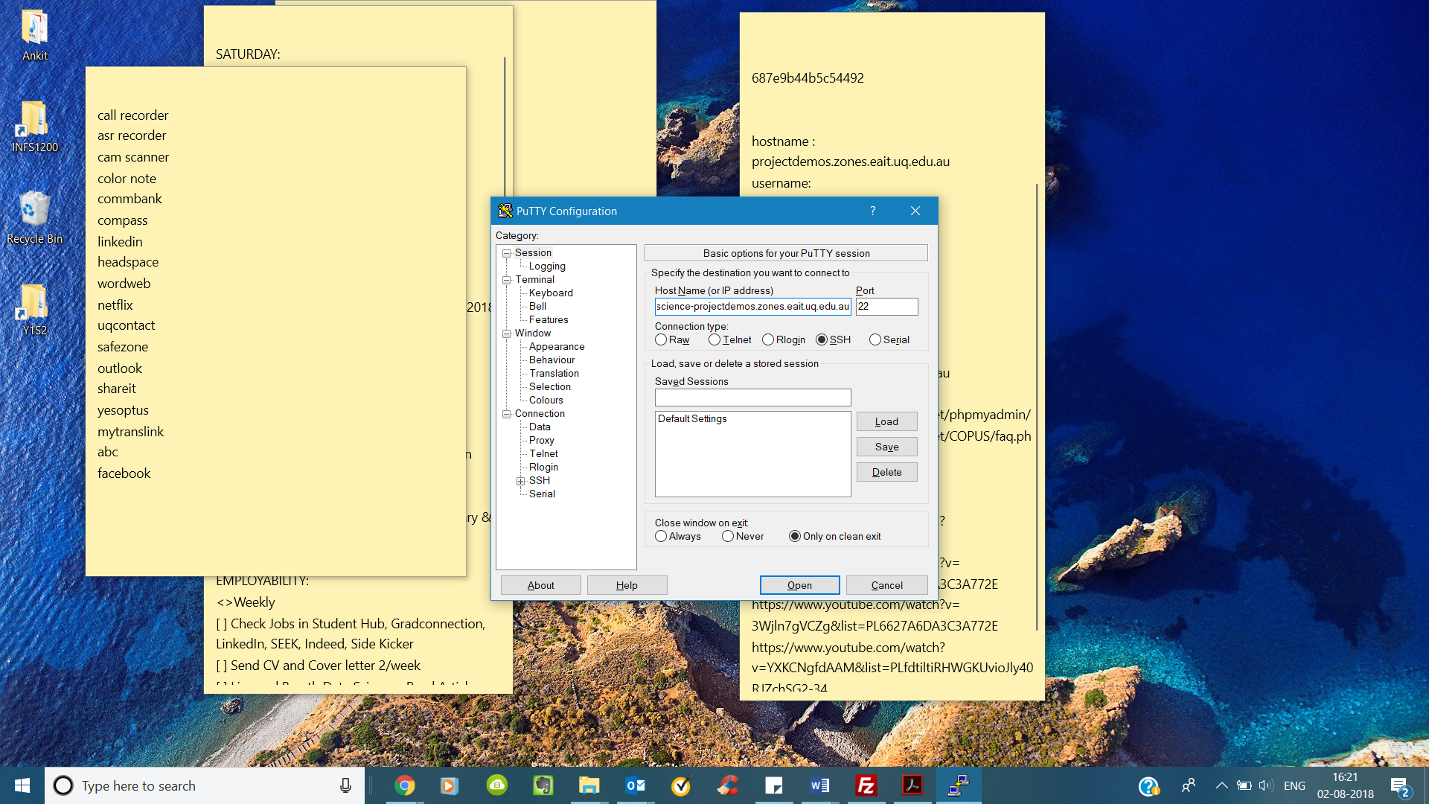

1. Use student ID and password to login

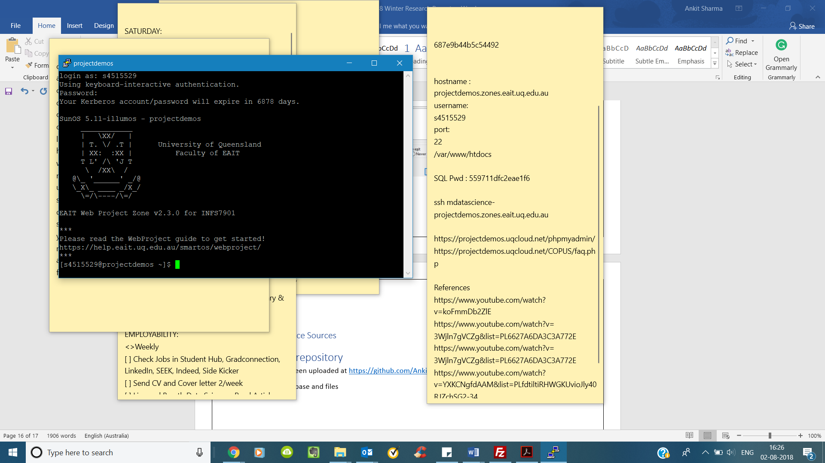

1. Go to the location var/log/nginx/

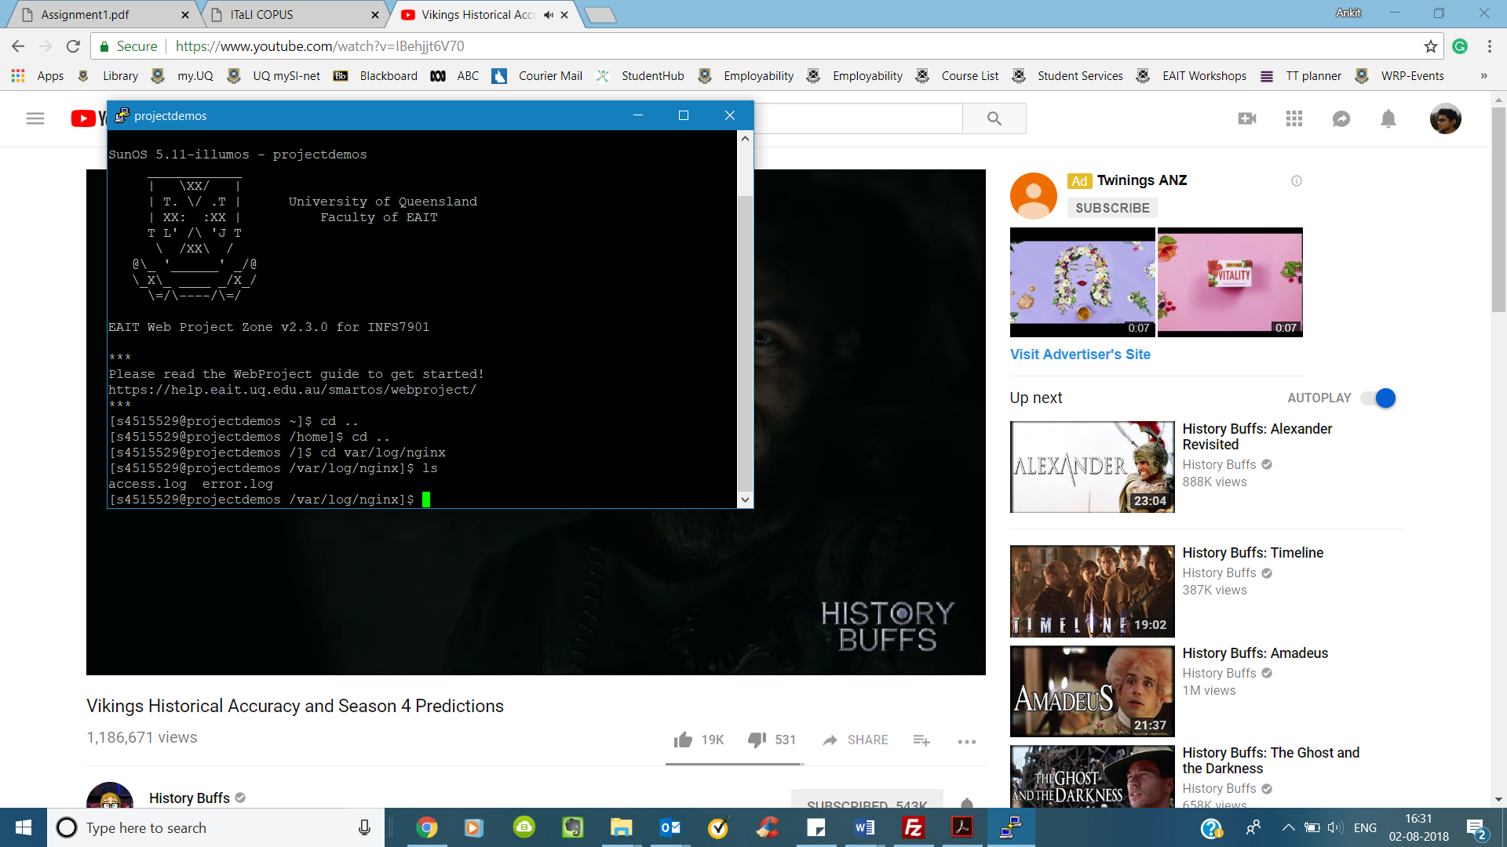

1. Enter tail -f -n 50 error.log to access last 50 lines of error.log

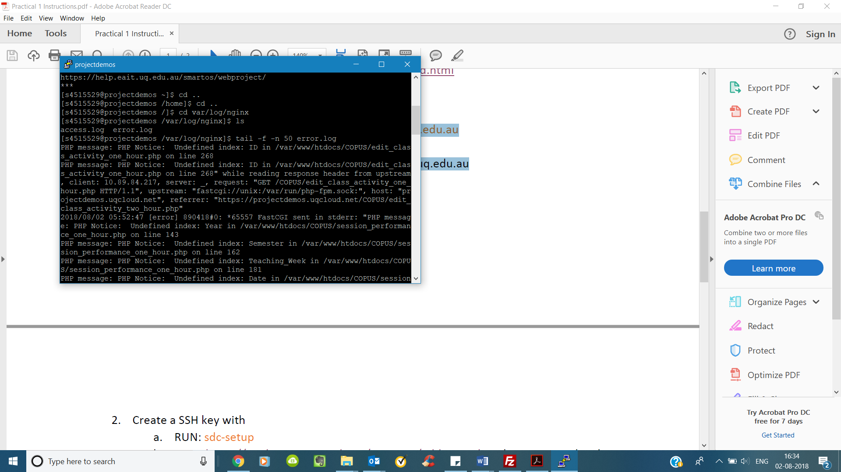

## Reference Source

* The website design is an inspiration from <https://colorlib.com/polygon/gentelella/>
* Chartjs is used to create graphs

# Github repository

The webpages and database creation file are present in the github repository [here](https://github.com/hkhosrav/Classroom-Observation-Protocol-)